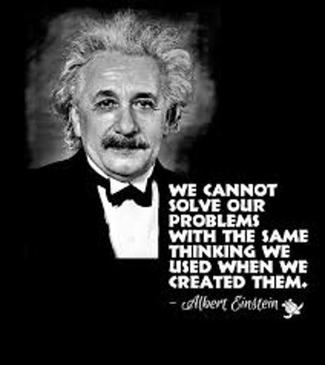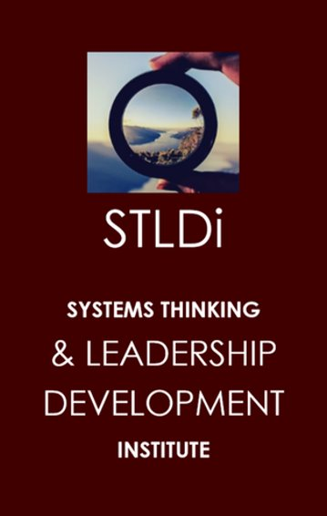

LEADERS OF SYSTEMIC CHANGE

PRESS KIT: MAY 8, 2021 (SATURDAY)

SYSTEMS THINKING LEADERSHIP DEVELOPMENT INSTITUTE (STLDi)
Press release: Embargoed till 9 am may 8, 2021
A Systems Thinking view of the unemployment concern in Botswana, changing the narrative: A presentation by STLDi during the organisation’s official launch.
GABORONE, 08 May 2021- STLDi today celebrates the official launching of rollout of its programmes in Africa, Botswana – Gaborone.
Systems Thinking and Leadership Development Institute has been established in Botswana since 2012. Its story in the country began as it offered strategy development consultancy to the government of Botswana for its 2008-2012 NDP efforts. It also offers leadership development programmes for public and private sector organisations.
We offer training, research and strategy development for leaders to develop the confidence and habits required in making systemic impact (affecting the whole of something). This training allows leaders to become skilled at enhancing individual and collective capacities to understand complex, inter-dependent issues, engage in reflective and generative conversations; and nurture personal as well as shared aspirations for their organizations.
Attending to the Press Brief were representatives of different media houses in Botswana. When presenting, the Director of STLDi cited that the strategy development is research informed and the approach to research is systemic, refer to the unemployment study link to one of our research works (https://sheilasingapore.wordpress.com/case-study-national-unemployment-botswana-short-notes/). Our methodology is not prescriptive, rather we embark on a co-discovery journey with our clients, uncovering systemic causalities that underlie their realities. This way, allow the client to better decide strategies. These strategies shape actions needed to turn persistent issues around. The work is based on ideas and methods developed since the 1990s and first started rolling in Botswana in the mid- 2000s and now as an organization.
Recognising the need for systemic thinking and strategy development to curb arising issues in Botswana, our services are targeted at sectoral and national clients in turning their persistent issues around. Some of these issues being unemployment, economic downturns, level of agricultural outputs, quality of education standards, despite ongoing efforts to curb their impact. We believe every leader when equipped with the skills and trainings will benefit from this program hence the need to be part of our upcoming trainings.
Based in Gaborone-Botswana - STLDi is founded by Sheila Damodaran, a corporate trainer whose practice spans 25 years and a strategy development consultant working with regional, national and sectoral leaders develop the confidence and habits one would need to make systemic impact on as well growth of their nation and economies.
SYSTEMS THINKING LEADERSHIP DEVELOPMENT INSTITUTE (STLDi)
Who are we?
We are Systems Thinking and Leadership Development Institute and we have been established in Botswana since 2012 as a non-governmental Strategy Development consultancy organization. We offer training, research and strategy development for leaders to develop the confidence and habits required in making systemic impact (affecting the whole of something). This training allows leaders to become skilled at enhancing individual and collective capacities to understand complex, inter-dependent issues, engage in reflective and generative conversations; and nurture personal as well as shared aspirations for their organizations.
What makes our Strategy Development different?
Our strategy development is research informed and our approach to research is systemic, refer to the unemployment study link to one of our research works (https://sheilasingapore.wordpress.com/case-study-national-unemploymentbotswana-short-notes/).
Our methodology is not prescriptive, rather we embark on a core discovery journey with our clients’ systemic causalities that underline their realities in order to allow the client to better decide strategies. These strategies shape actions needed to turn persistent issues around. The work is based on ideas and methods developed since the 1990s and first started rolling in Botswana in the mid 2000s and now as an organization.
Why have we come here?
We are here because our services are targeted at sectoral and national clients in turning their persistent issues around, such as unemployment, economic downturns, level of agricultural outputs, quality of education standards, despite ongoing efforts to curb their impact. We approached you because we believe as a leader you can benefit from this program. For more information For more information, you can contact the Director of this organization directly via her contacts and blog which will be provided on the poster or through us, whereby we can arrange a meeting for both of you to meet.
ABOUT THE DIRECTOR The brains behind Systems thinking leadership development institute is Sheila Damodaran. She is a strategy development consultant working with regional, national and sectoral leaders develop the confidence and habits one would need to make systemic impact on as well growth of their nation and economies. She is a corporate trainer and her practice spans over 22 years. Please refer to the below link to her blog (https://sheilasingapore.wordpress.com/introduction/about/)

CONTACTS:

ADDRESS: | Plot 1888 Mogoditshane Botswana
MOBILE: | +267 76842205
DID: | +267 3101081
EMAIL: | ontiretses@stldibwsg.com

WEB PRESENCE:

Website: | https://pinnacleacademy.weebly.com/
Blog: | https://sheilasingapore.wordpress.com/about-stldi/
Case Study on unemployment: | https://sheilasingapore.wordpress.com/case-study-national-unemployment-botswana-short-notes/
LinkedIn Profile: | https://www.linkedin.com/in/sheilasingapore/

PROGRAMME

FOCUS: | Tackling the unemployment problem in Botswana systemically
DATE: | May 8th, 2021
VENUE: | Hilton Hotel @CBD
TIME: | 9am - 11 am
Facilitator: | Eunice Monnaatsie

- Arrival of guests & Covid registration _ Ontiretse Sickboy (15 minutes)
- Opening
- Opening Prayer – Volunteer (5 minutes)
- Welcome remarks and introductions – Phillip Katisi (2 minutes)
- Presentation on STLDi – Philip Katisi (20 minutes)
  - Shares on the history and setup of STLDi
  - Q: You are the leader of this nation. You hear the plea of its citizens for job creation and employment. What would you do? - (5 minutes) reflection and quiet discussions
  - Introduction of the next presenter Sheila Damodaran _Phillip Katisi
- Presentation on the systemic thinking study – Sheila Damodaran (30 minutes).
  - Learning Organization – What is it? And what is Systems Thinking (persistent issues)
  - Story on how the case study happened for Botswana
  - Introduce key elements of the study (complemented by the blog + flipchart use)
- Conclude the study – Q: Bring back question and ask, “What would you do now?” What would need to happen? How do we engage the nation? The masses? (10 minutes).
- Strategic Leadership the STLDi way! Also talk to the research and training division? – Philip Katisi (5 minutes).

- Questions and comments – Facilitator (15 minutes)

- Vote of thanks (3 minutes)
C. Break _ 10 Minutes

